Bartman MERN Project
Table of Contents
Mern Document 1
Launch, setup and connect EC2 Instance 1
Connect terminal: update and install node.JS 1
Create project on Mongodb Atlas, configure user, create cluster 2
rr 2

Mern Document

Launch, setup and connect EC2 Instance
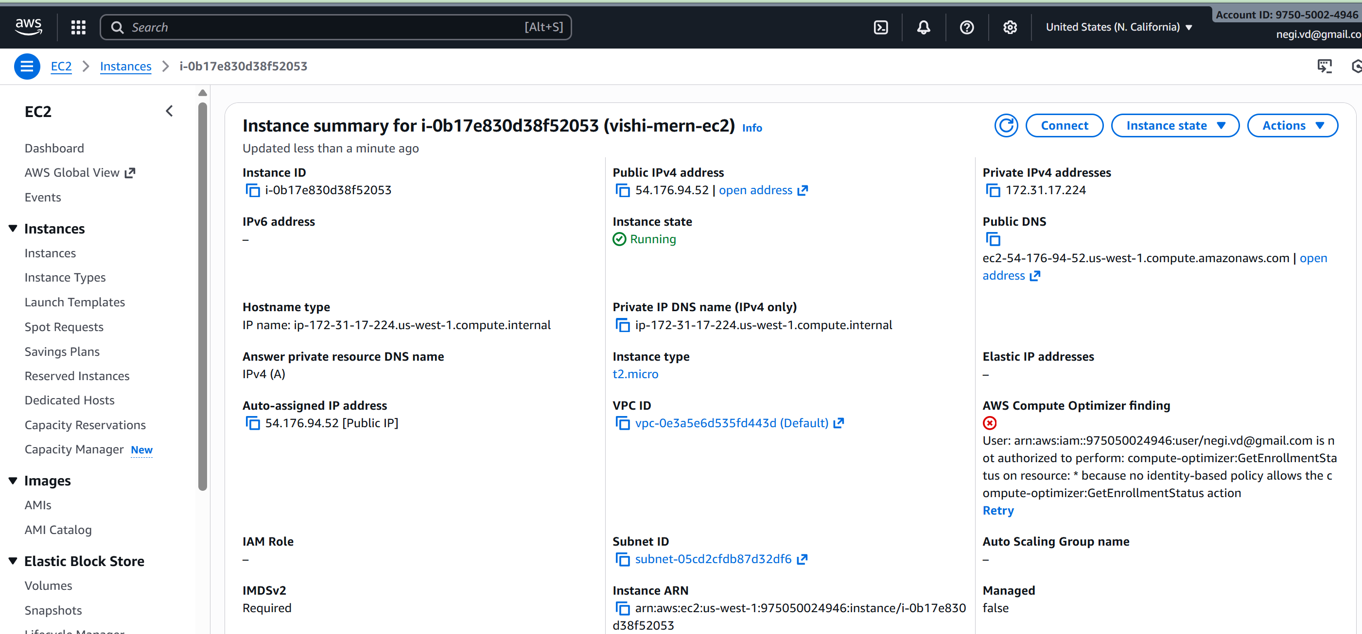

Connect terminal: update and install node.JS

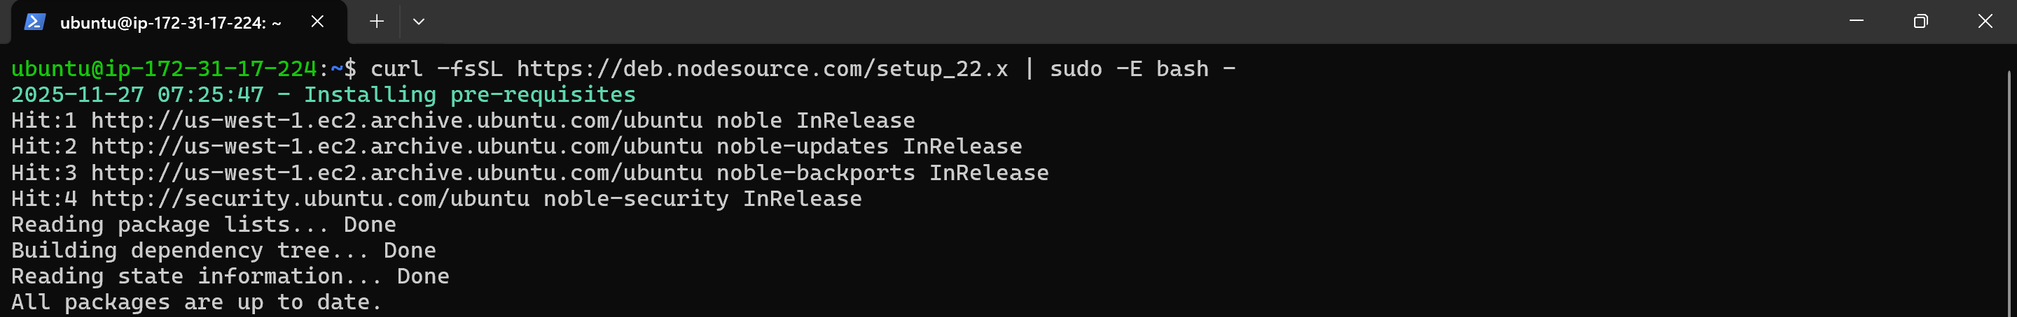
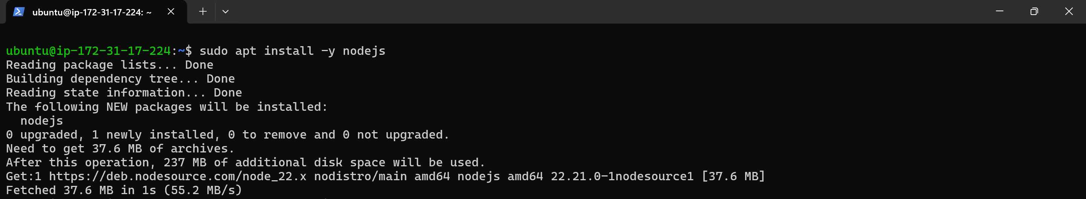
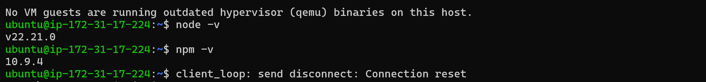

Create project on Mongodb Atlas, configure user, create cluster
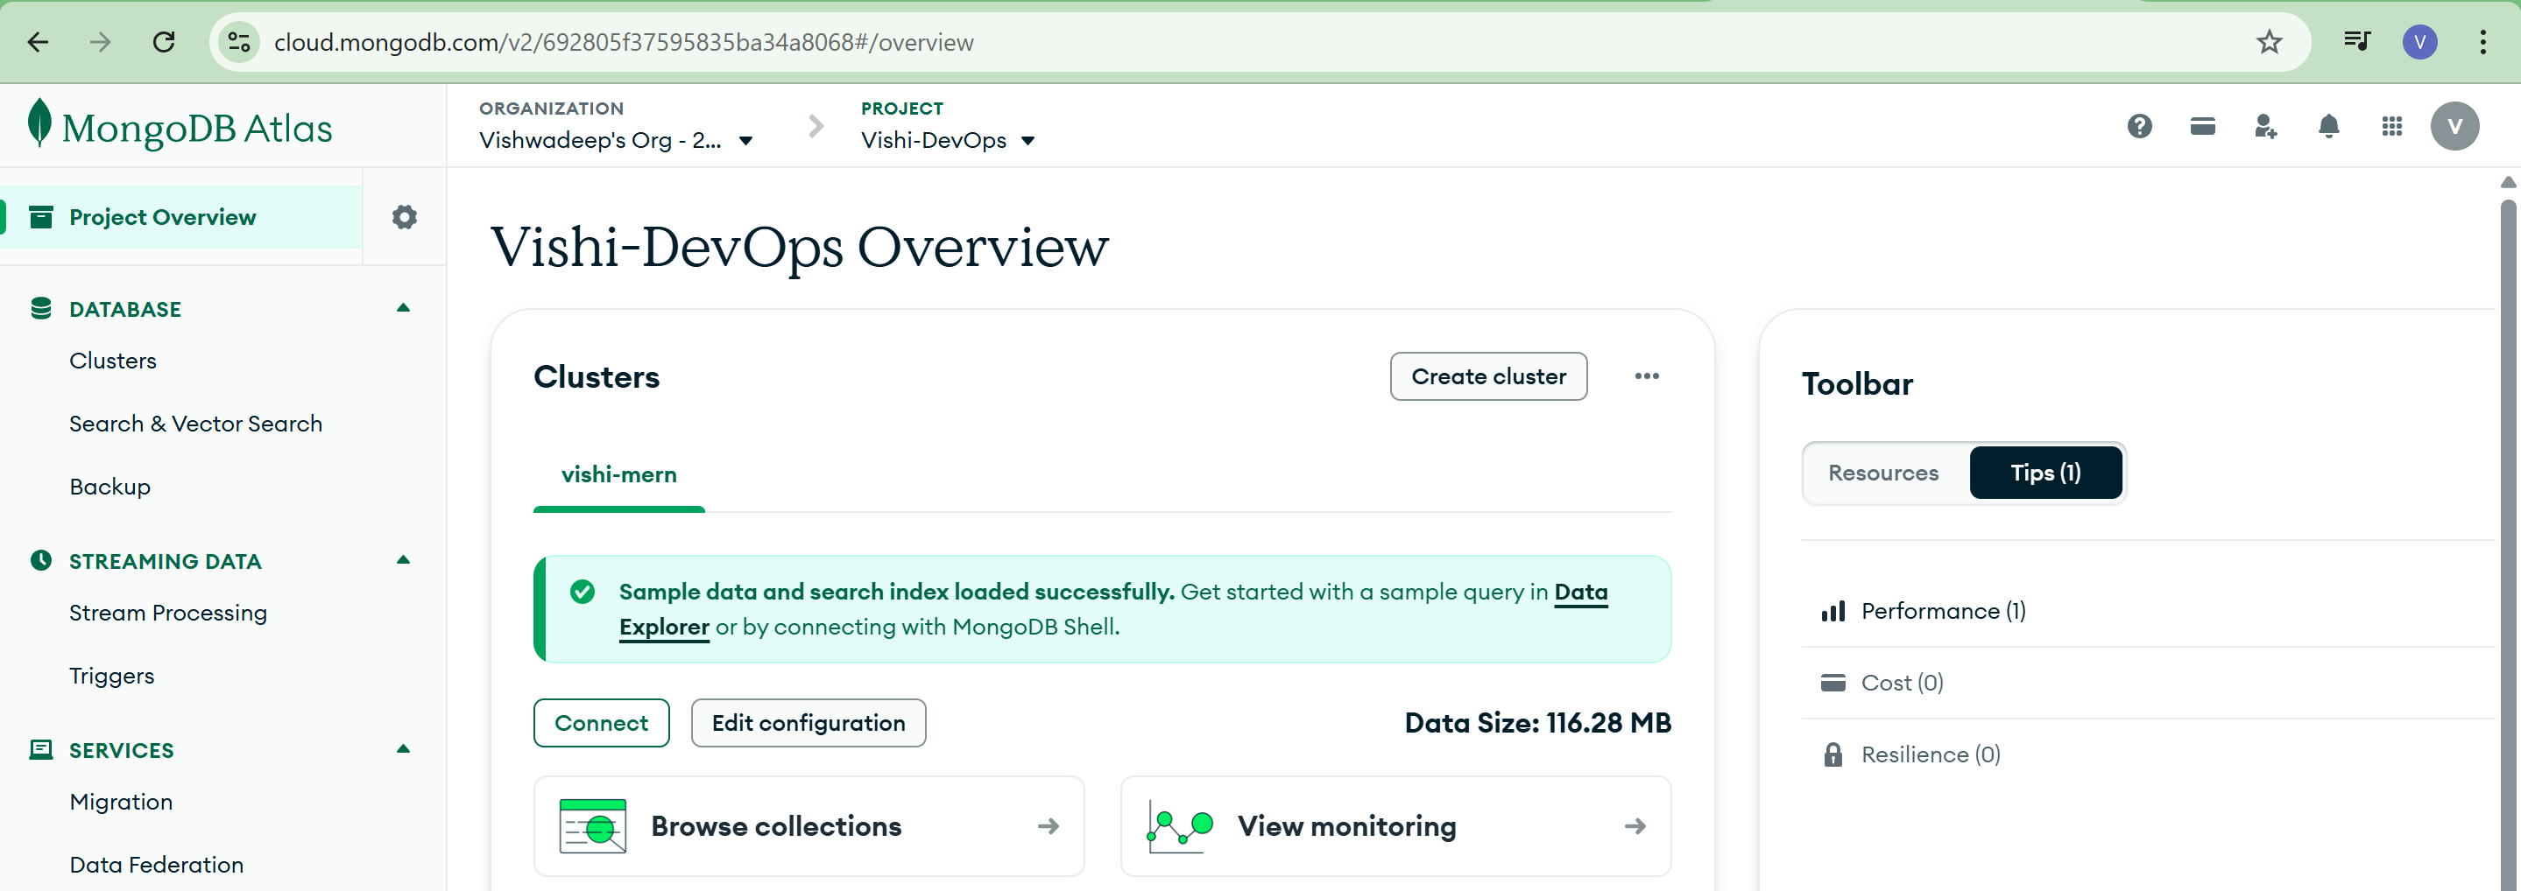

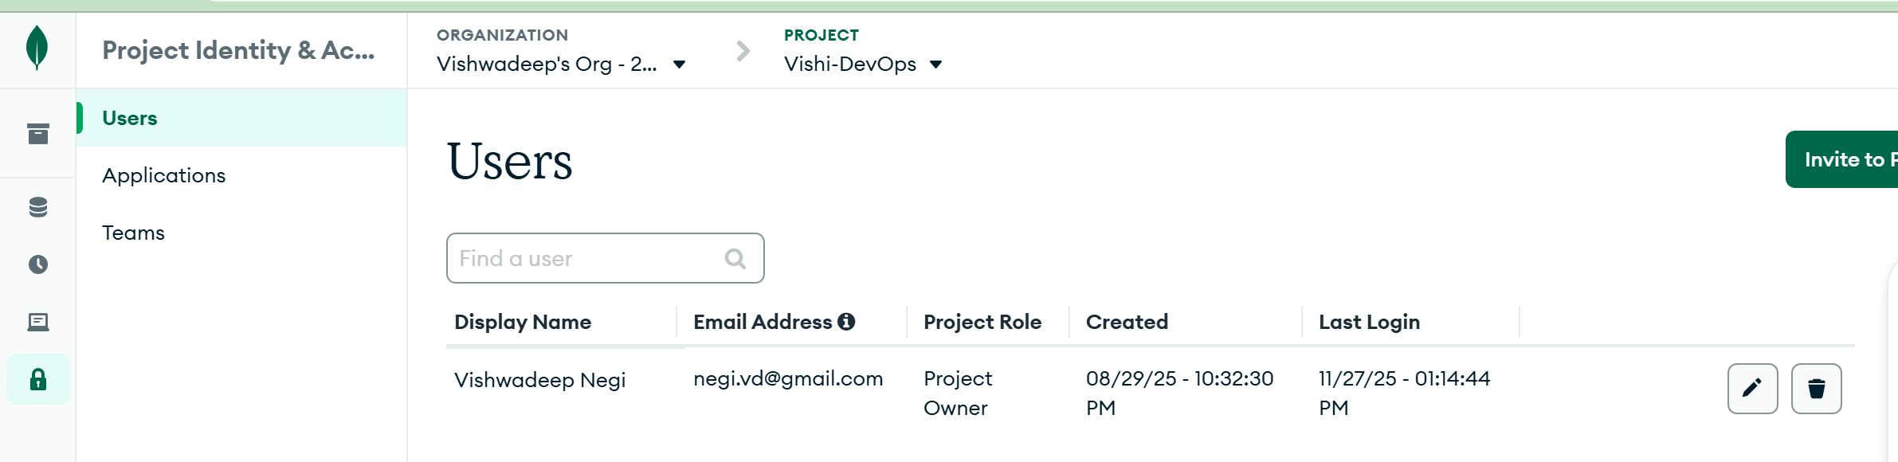

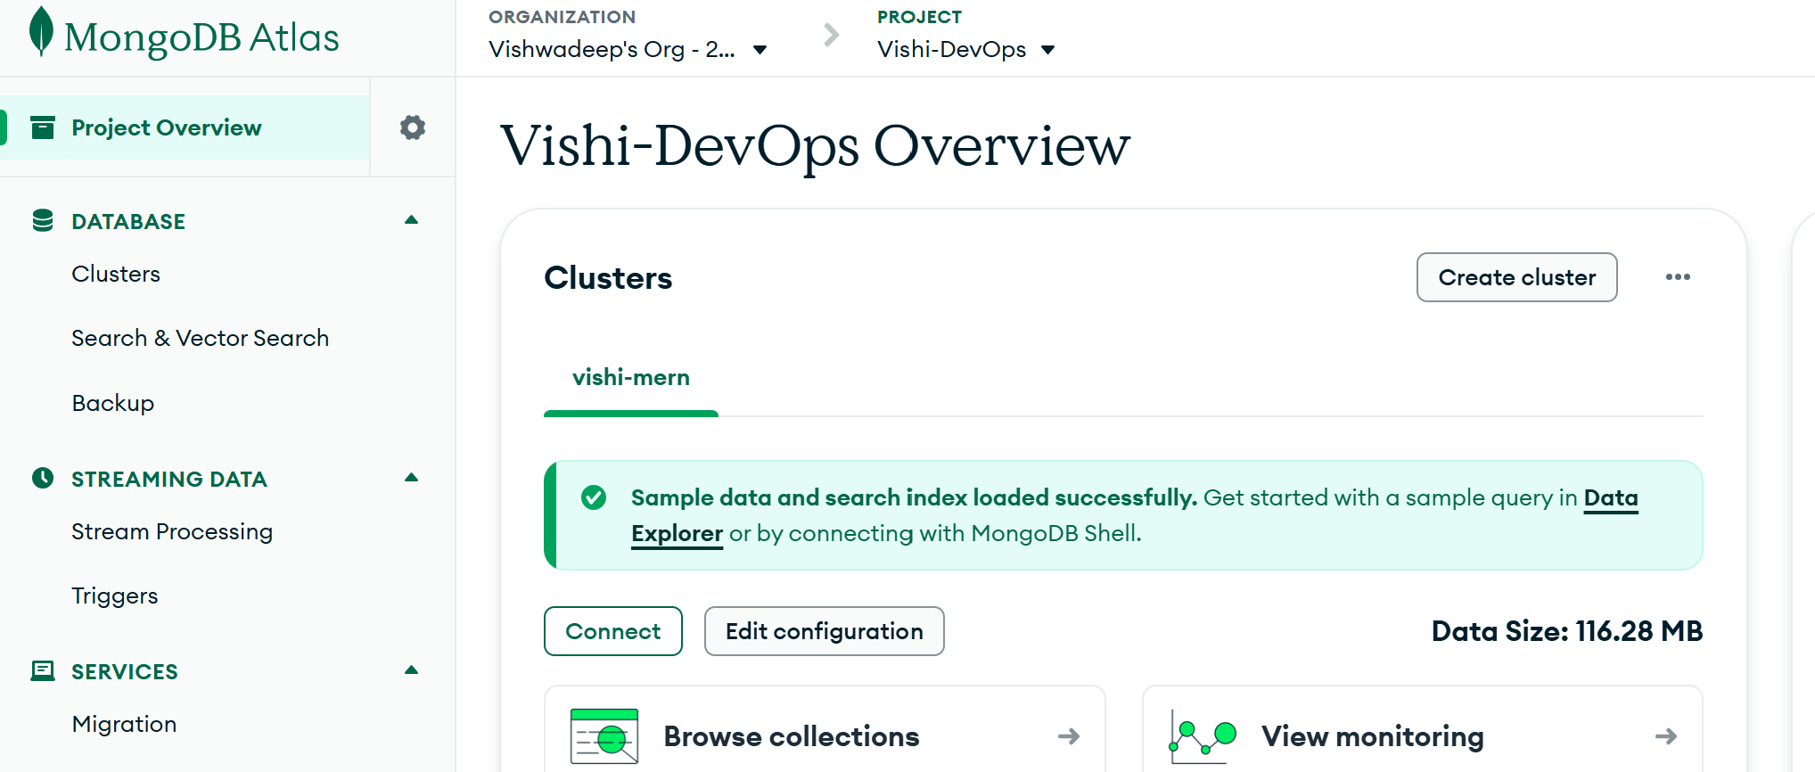

Connect the database on Mongodb compass
Use the URI, connect to Mongodb compass create database and add documents in database
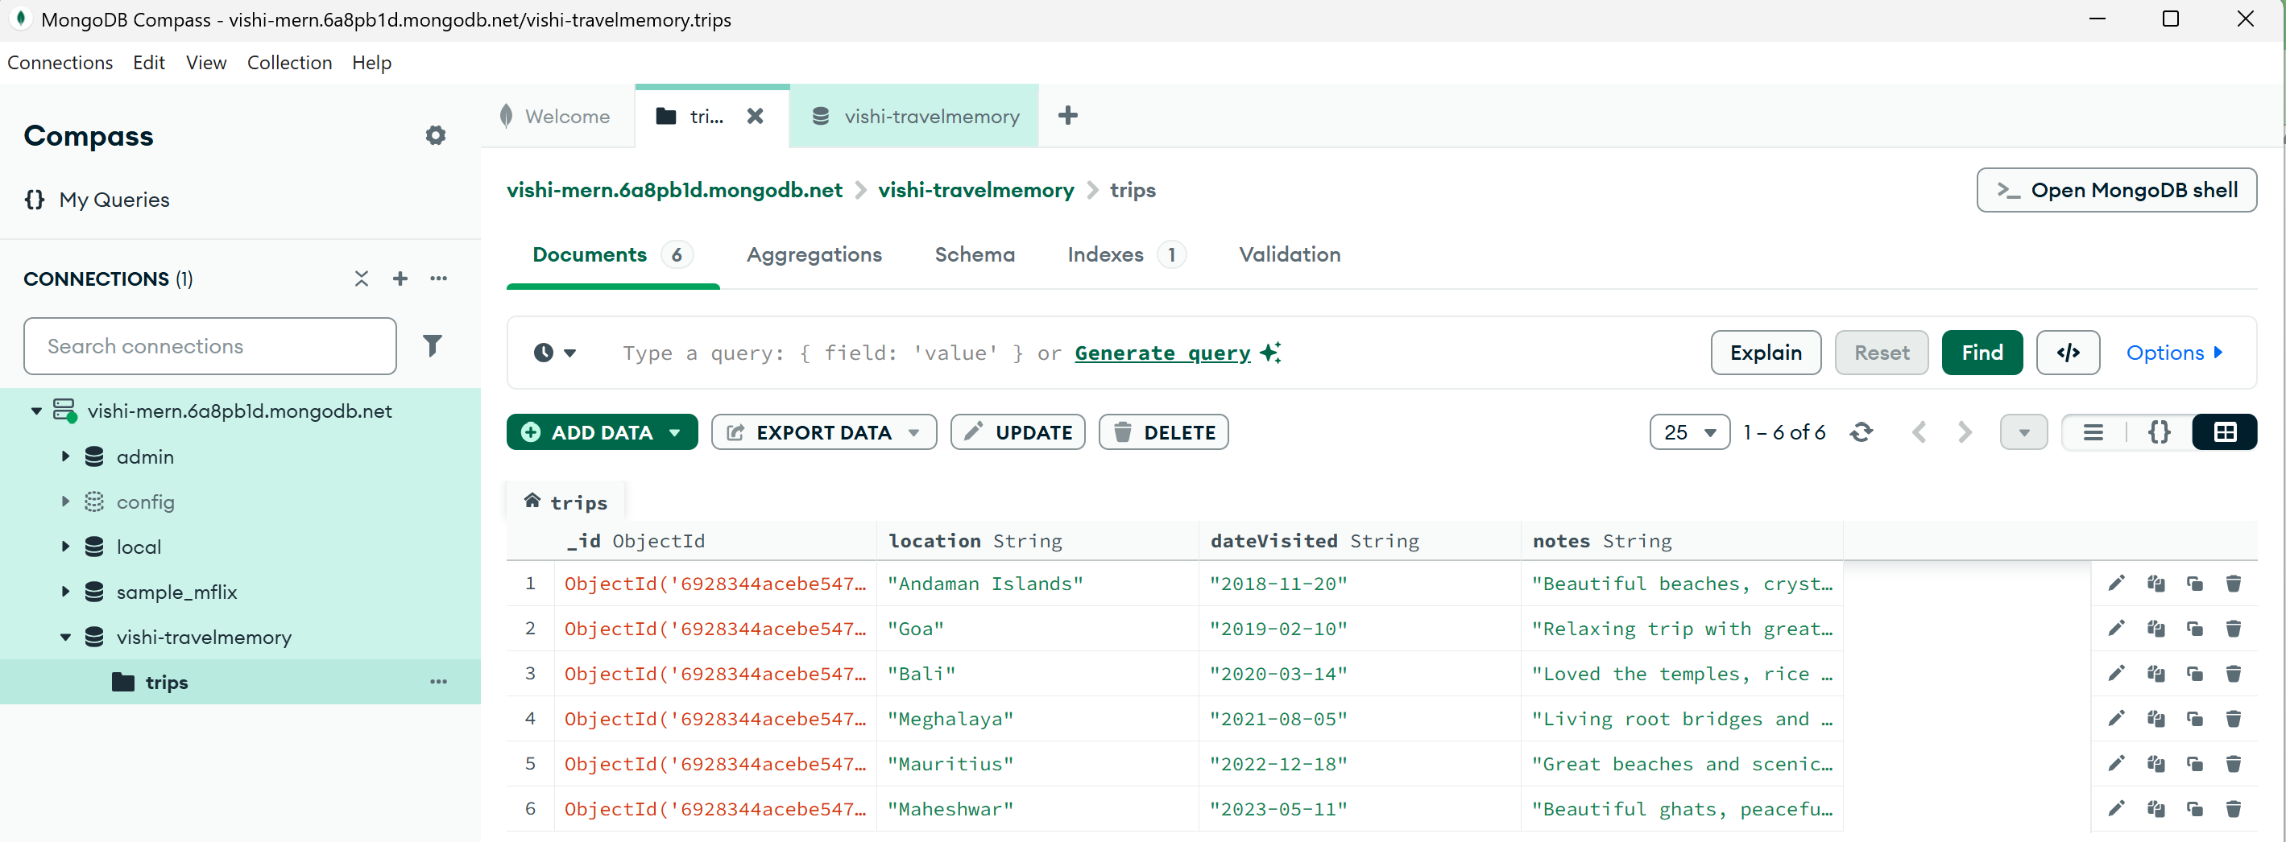

Git repository

Clone the repository

Create.env file

npm install

Run backend application

Test the API Endpoint
